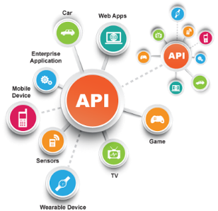**SE495 Software and Systems Integration**

**Develop an API for a hypothetical library management system**

**Part 1**: Identify the services needed for a library management system based on SOA principles. Some examples could be:

* Registering new members
* Adding new books
* Issuing/returning books
* Managing fines and payments

Students should identify at least 5-6 such core services that cover the major functionality. They can create a diagram to show the high-level SOA for the system.

**Part 2**: Develop RESTful APIs for two of the identified services. For example, they can design:

* An API for new member registration with endpoints for adding a new member, validating membership number, etc.
* An API for issuing/returning books with endpoints for checking out a book, returning a book, renewing a book, etc.

The students should define proper HTTP methods, status codes, request/response payloads, URI templates, etc. for the APIs.

**Part 3**: Develop partial API documentation for the APIs created in Part 2 using OpenAPI specification (formerly Swagger). The documentation should include information like API versions, endpoints, parameters, responses, schemas, examples, etc.

**Part 4**: Discuss pros and cons of REST vs SOAP for building APIs for the library system. Explain your choice of REST for this project. Also discuss best practices for versioning, security, caching, etc. for the APIs.

**Part 5**: Reflection - Students reflect on what they learned from designing the APIs and documentation.

* How can they continue to improve the APIs?
* What other services can be built for the library system?
* How will they manage the APIs?
* Discuss future enhancements and roadmap.

This guided project allows students to apply key concepts of SOA, APIs, REST, and API documentation in a systematic manner. They can gain hands-on experience in designing and developing APIs, which will be very useful as software and systems integration professionals. Please let me know if you would like me to elaborate on any specific parts of this suggested project. I can provide more details and pointers.